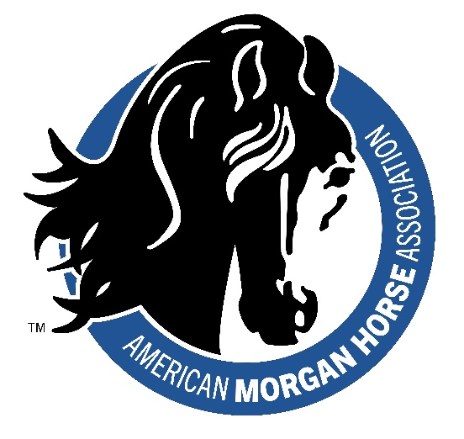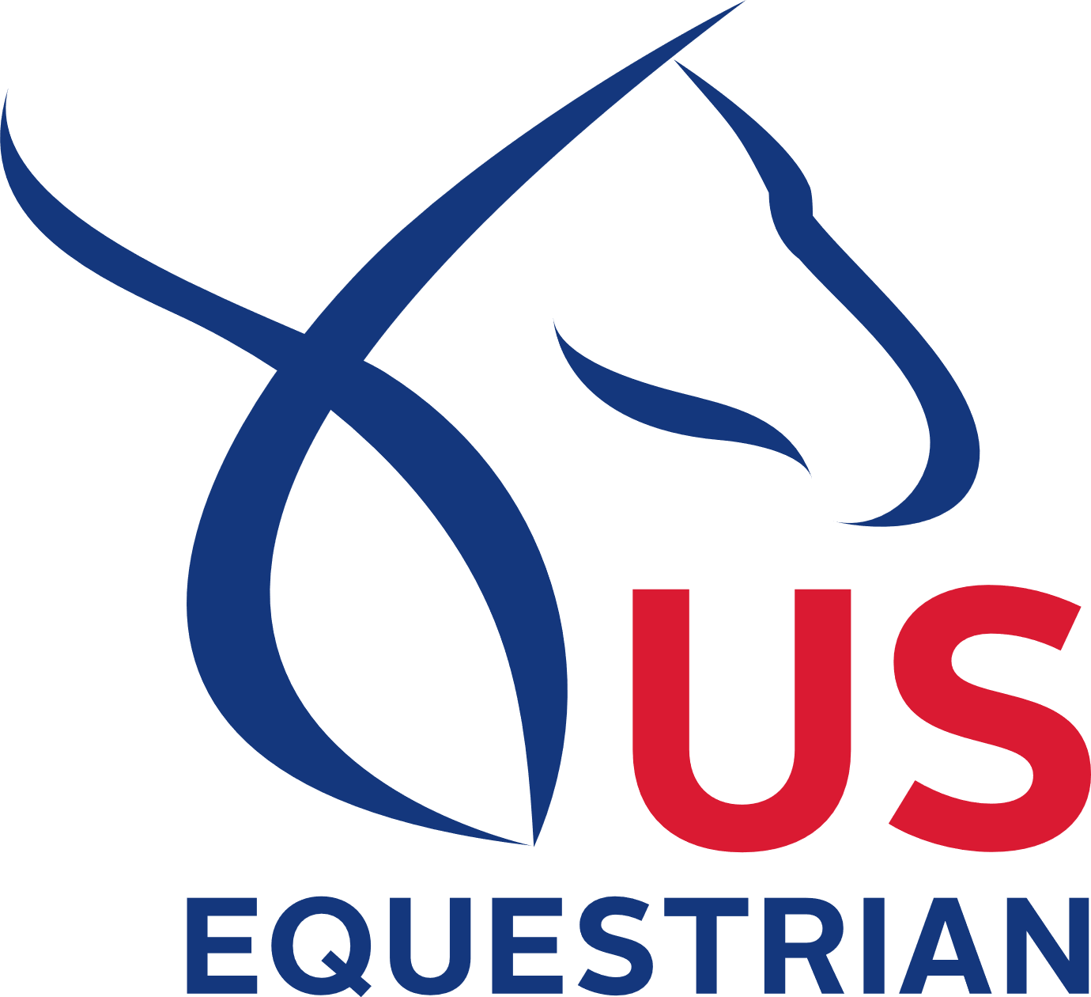

AMHA/USEF Rule Forum

Some of the proposals include allowing the use of supplemental hair, allowing any type of pad in Classic Pleasure (leaving the length requirement as is), allowing all Western horses to show in a snaffle bit, and clarifications to several class specifications. Be sure to attend and have your input noted.
Whether these rule changes will be officially submitted and move forward in the USEF process (with possible effective dates of 12/1/2023) will depend on the input received from the AMHA membership base.
We look forward to seeing you at the rule forum and recording your thoughts on these proposals.

Date:
Time:
Location:
Contact:

